**UML DIAGRAMS**

# **CLASS DIAGRAM**

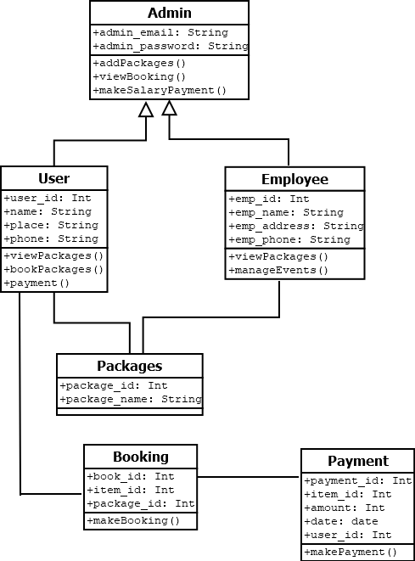

# **OBJECT DIAGRAM**

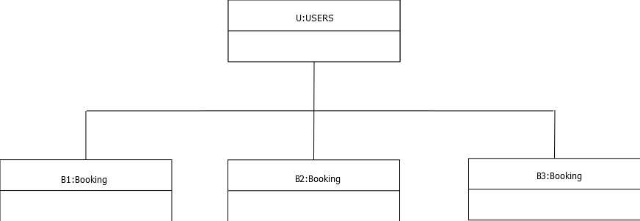

**DEPLOYMENT DIAGRAM**

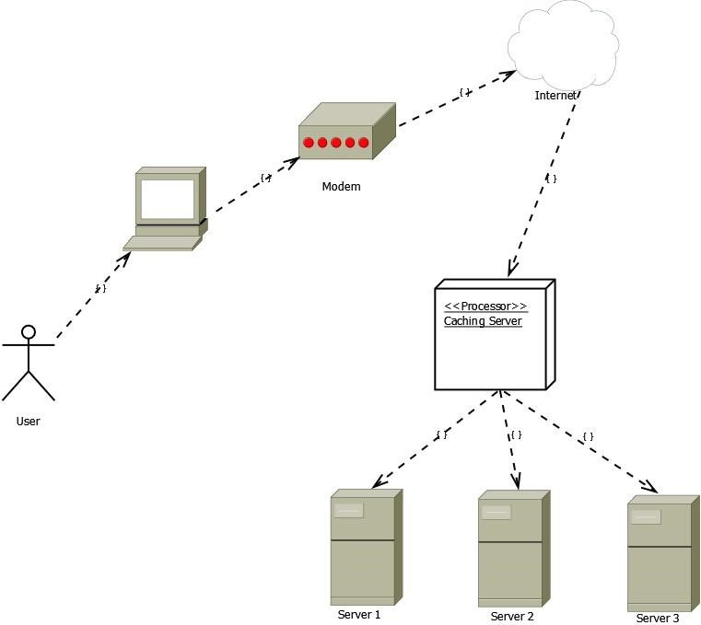

**BEHAVIOUR DIAGRAM**

**USECASE:**

Employee

Admin

User

# **SEQUENCE DIAGRAM**

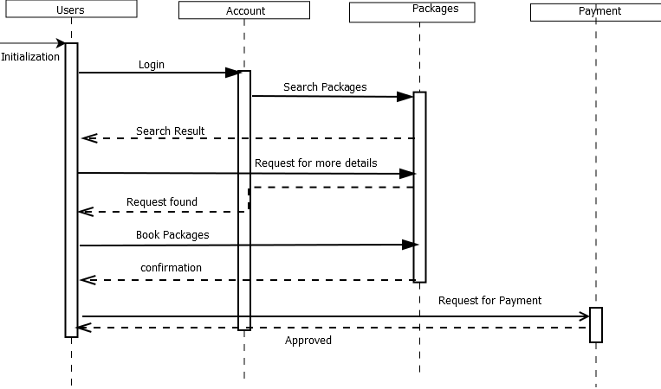

# **COLLABORATION DIAGRAM**

Initialization

New Customer

3. Payment

2. Book packages

1. Login()

Make Payment

End of process

Select Packages

View Packages

Registered Users

# **STATE CHART DIAGRAM**

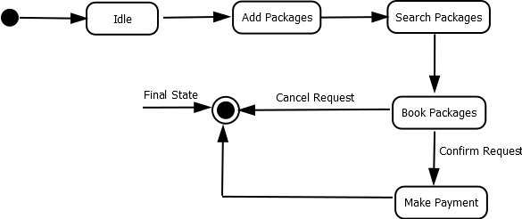

# **ACTIVITY DIAGRAM**

